**Execute all the join with examples.**

Joins in SQL are used to combine rows from two or more tables based on related columns. This allows for the retrieval of information that combines multiple tables within a database, helps for data analysis.

Here we are Creating Two tables:

1. Course Table

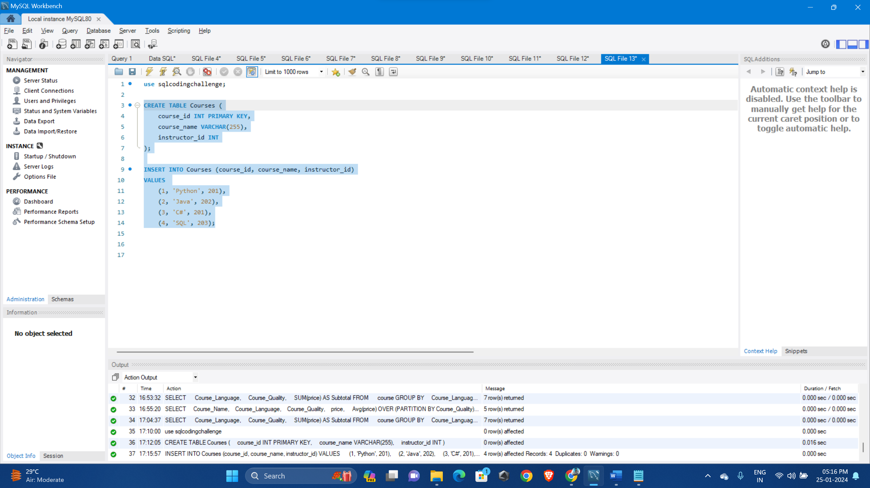

1. Details Table

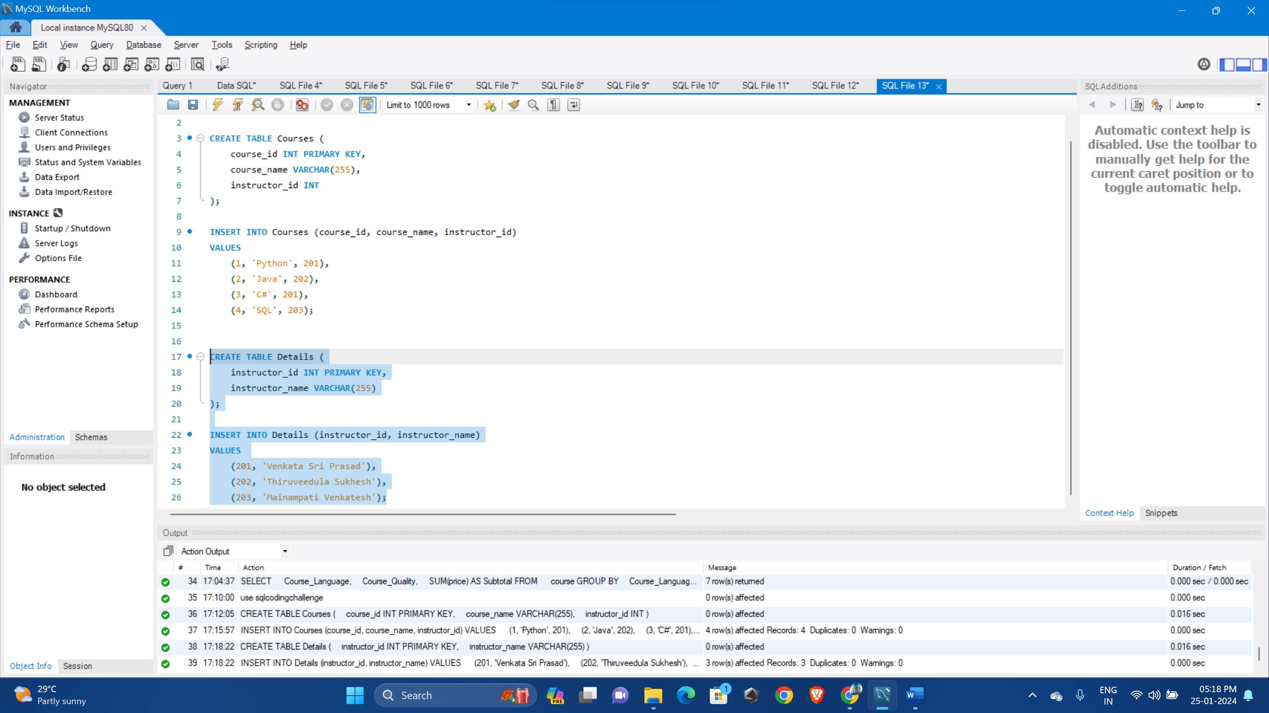

There are different types of joins and let’s understand them by executing:

**1. Inner Join:** Retrieves rows where there is a match in both tables, excluding non-matching rows.

SELECT * FROM Courses

INNER JOIN Details ON Courses.instructor_id = Details.instructor_id;

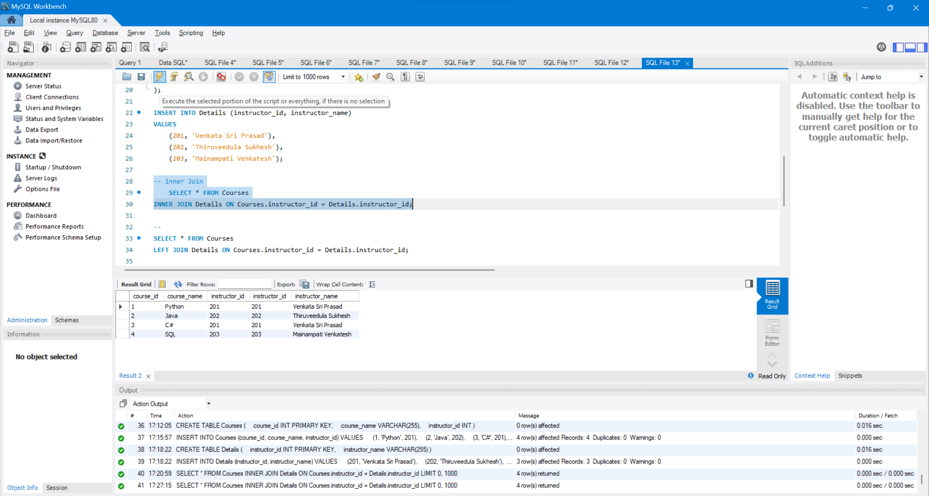

1. **Left Outer Join:** Retrieves all rows from the left table and matched rows from the right table; non-matching rows in the right table contain NULL values.

SELECT * FROM Courses

LEFT JOIN Details ON Courses.instructor_id = Details.instructor_id;

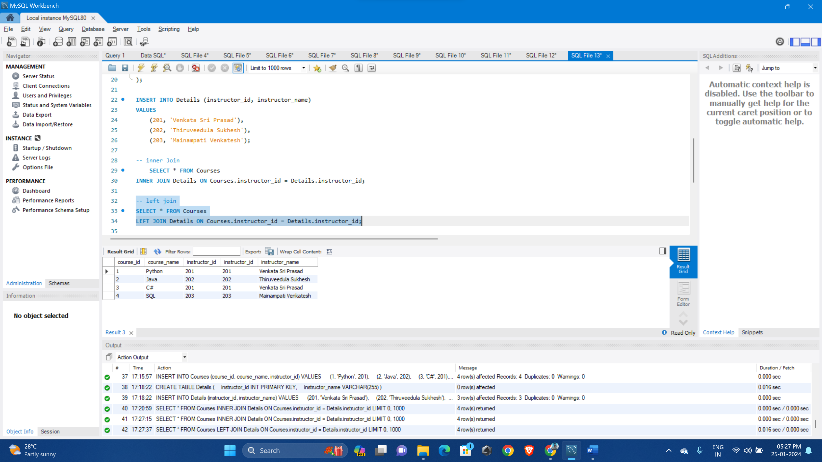

1. **Right Outer Join:** Retrieves all rows from the right table and the matched rows from the left table. Non-matching rows from the left table contain NULL values.

SELECT * FROM Courses

RIGHT OUTER JOIN Details ON Courses.instructor_id = Details.instructor_id;

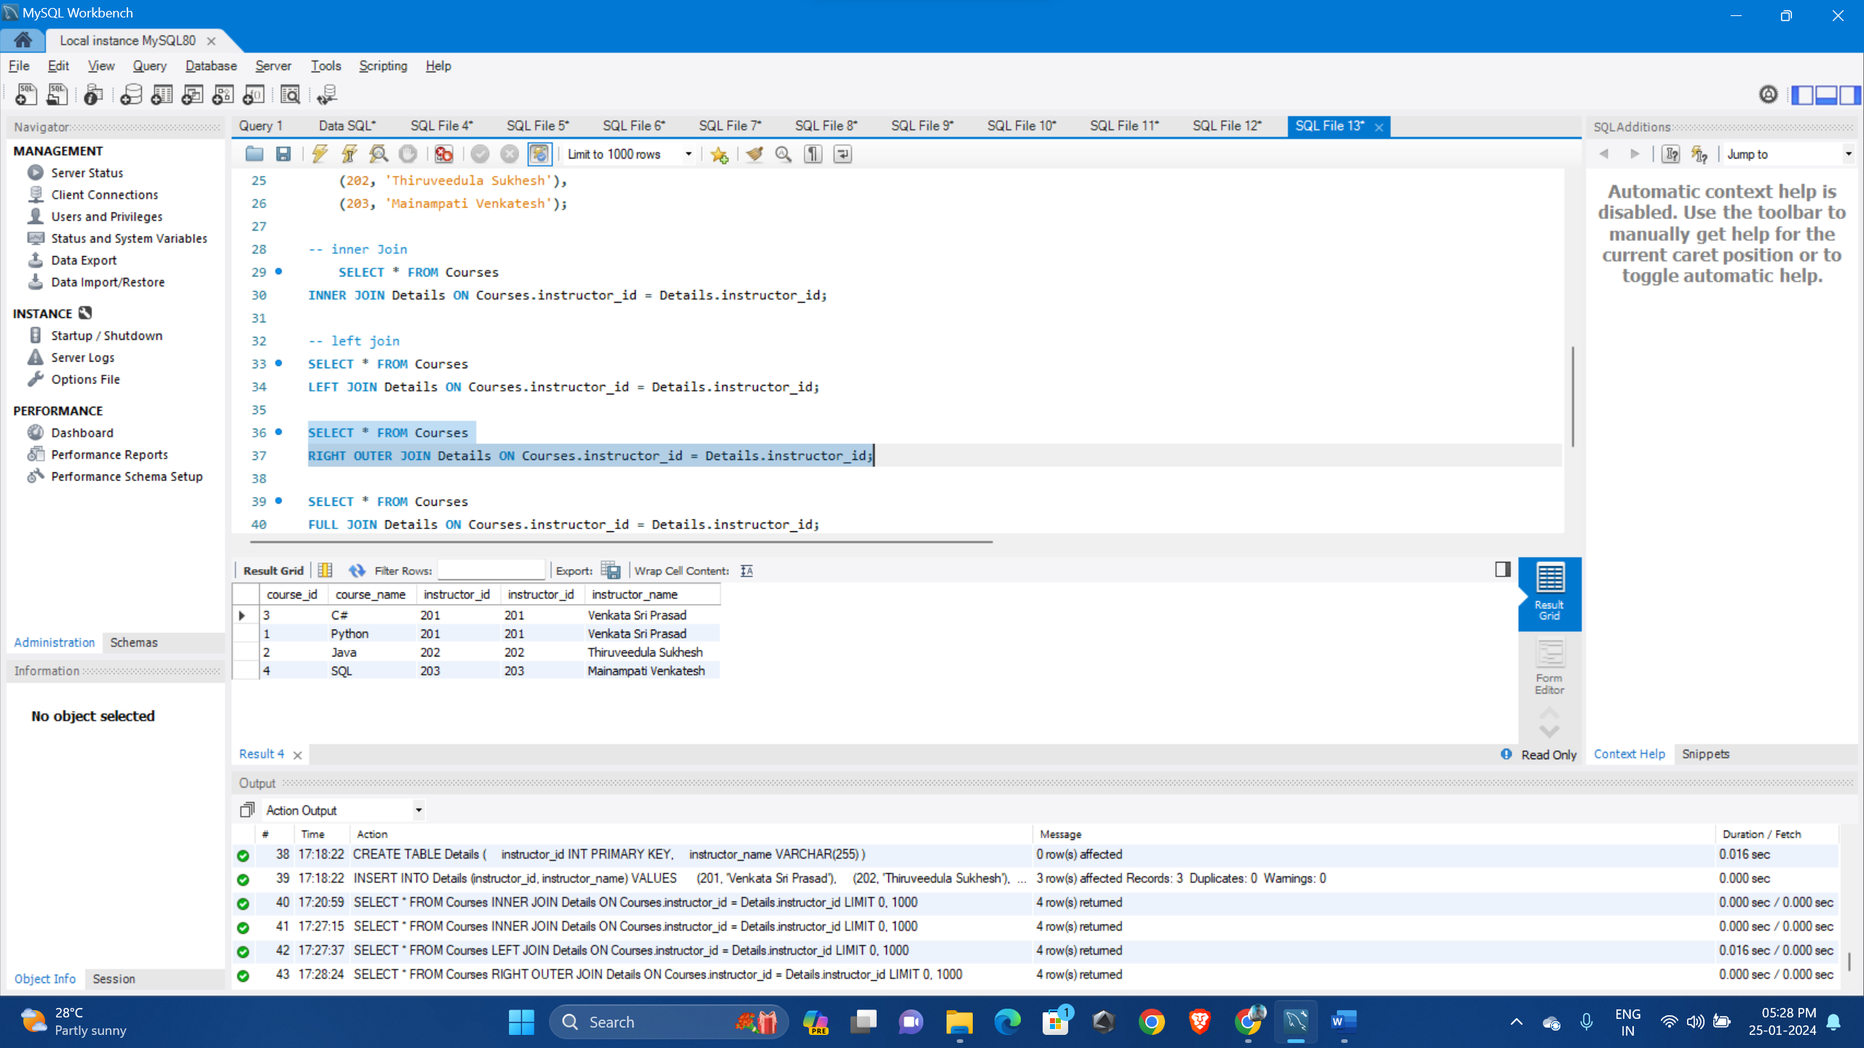

1. **Full Outer Join:** Retrieves all rows when there is a match in either table, filling in NULL values for non-matching rows in both tables.

SELECT * FROM Courses

FULL JOIN Details ON Courses.instructor_id = Details.instructor_id;

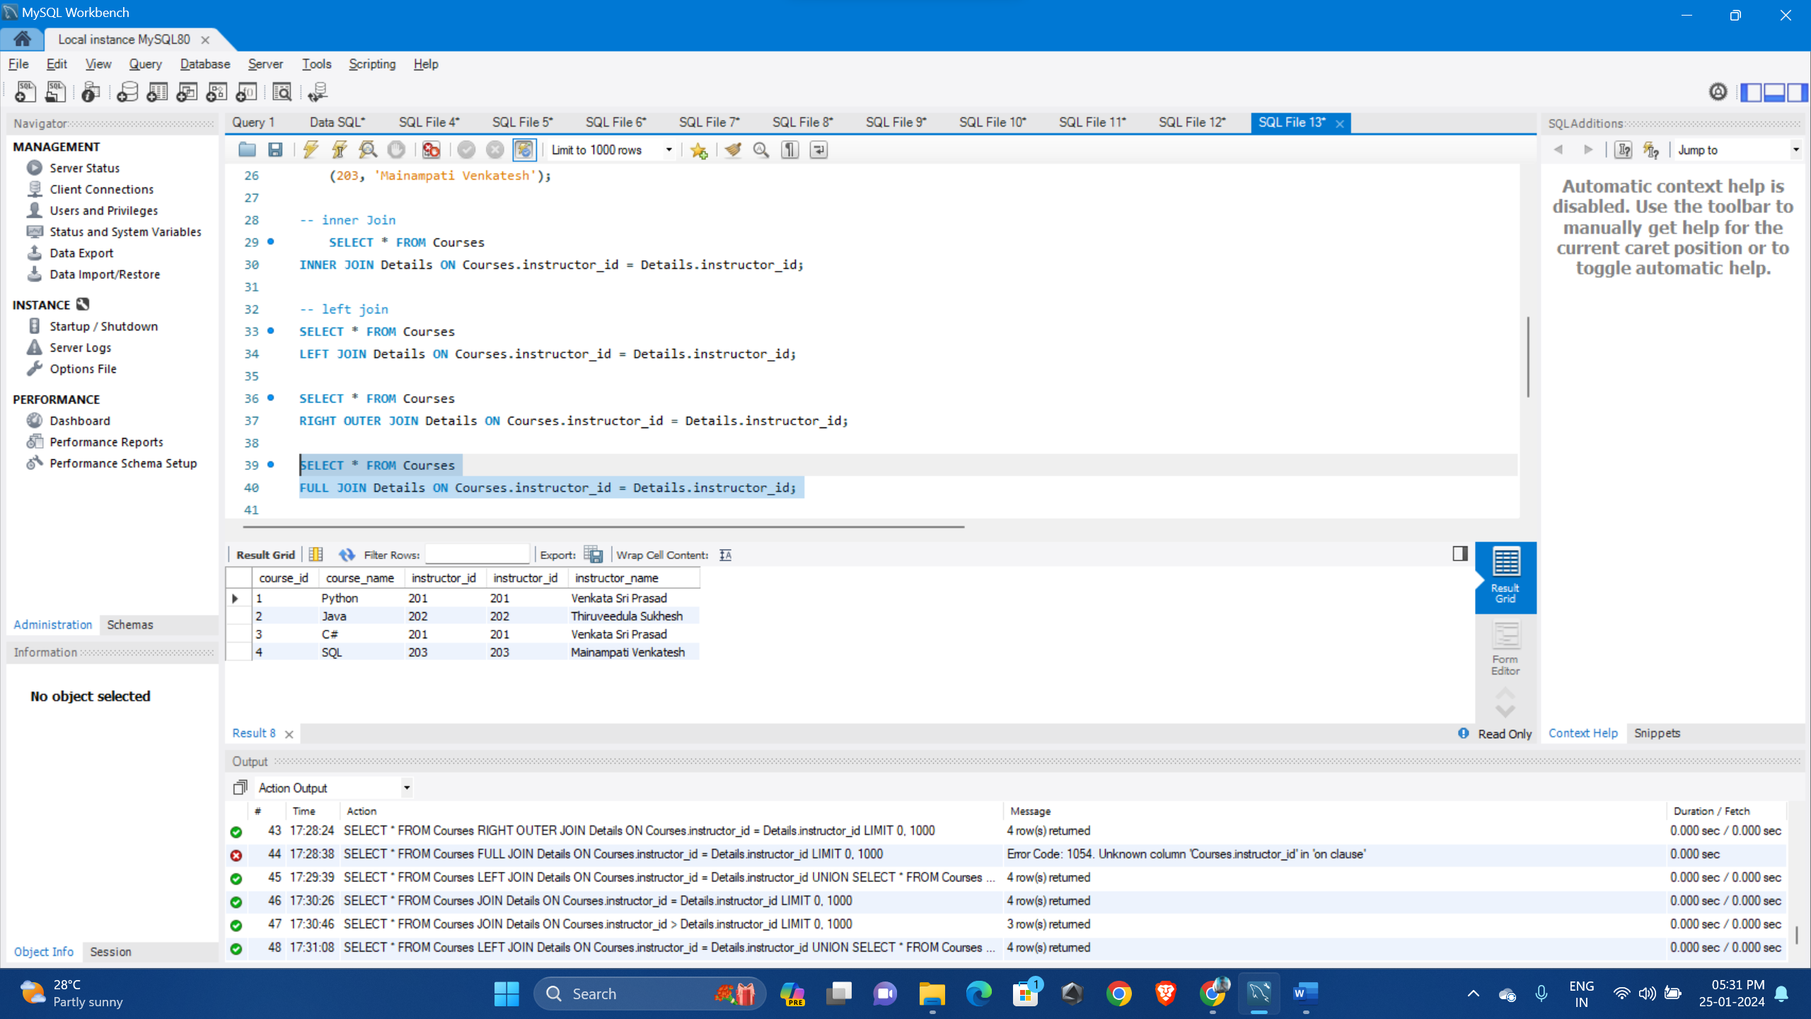

1. **Natural Join:** Automatically joins tables based on columns with the same name, simplifying the query.

SELECT * FROM Courses

NATURAL JOIN Details;

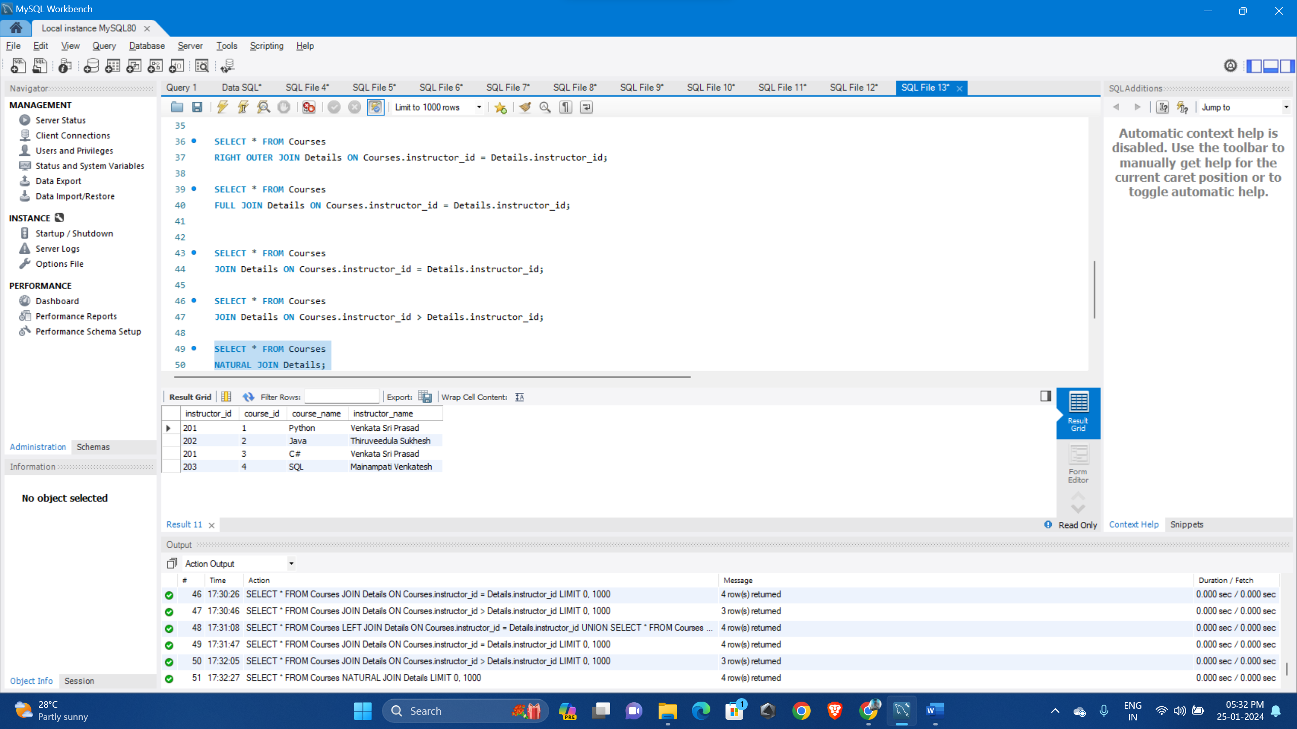

1. **Equi Join:** Retrieves rows from two tables where specified columns have equal values, creating a result set based on equality conditions.

SELECT * FROM Courses

JOIN Details ON Courses.instructor_id = Details.instructor_id;

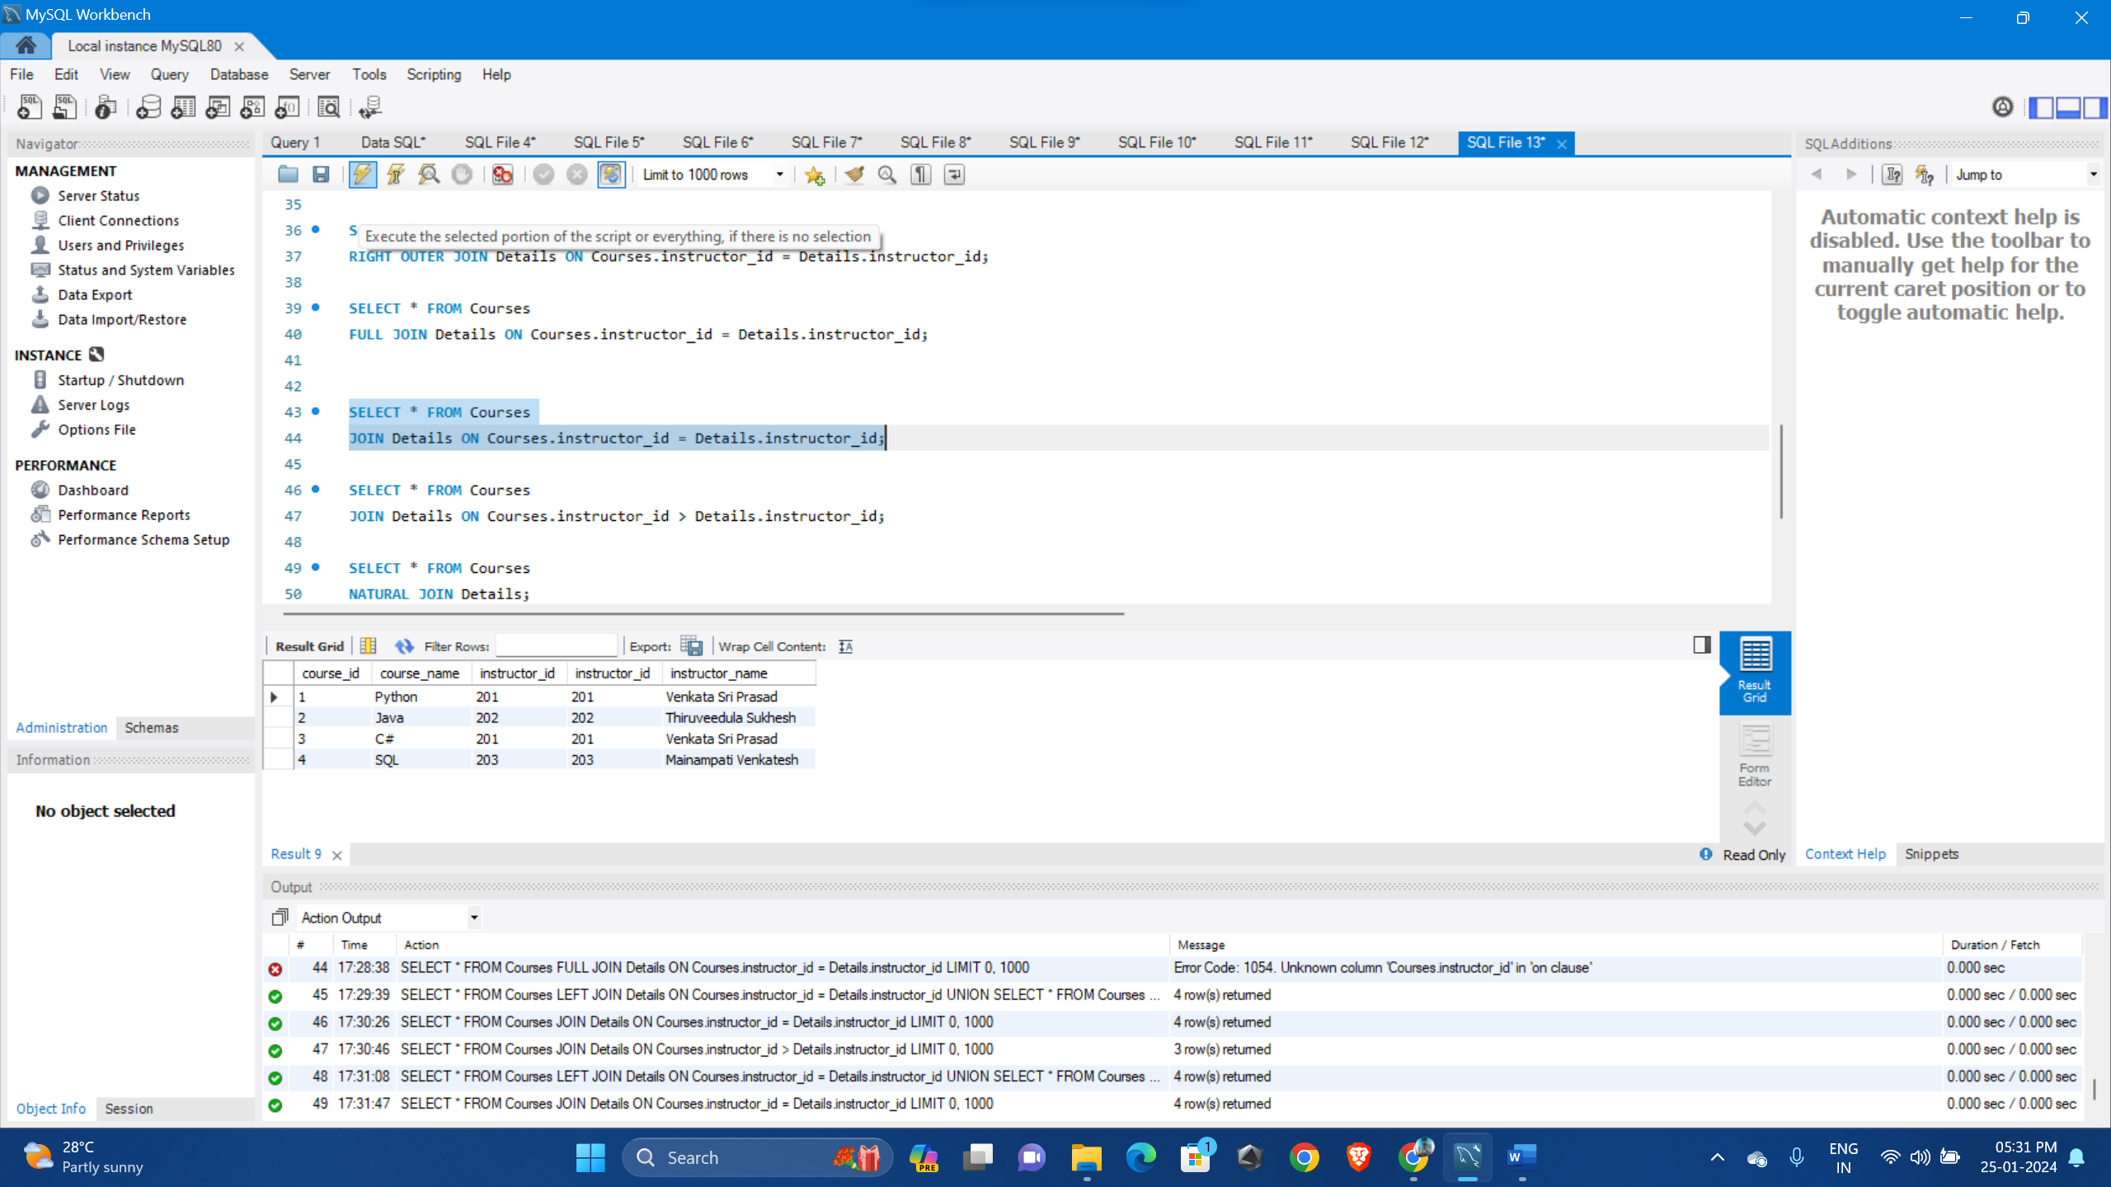

1. **Non-Equi Join:** Retrieves rows from two tables based on conditions other than equality, such as using greater than or less than operators, allowing for more flexible data comparisons.

SELECT * FROM Courses

JOIN Details ON Courses.instructor_id > Details.instructor_id;

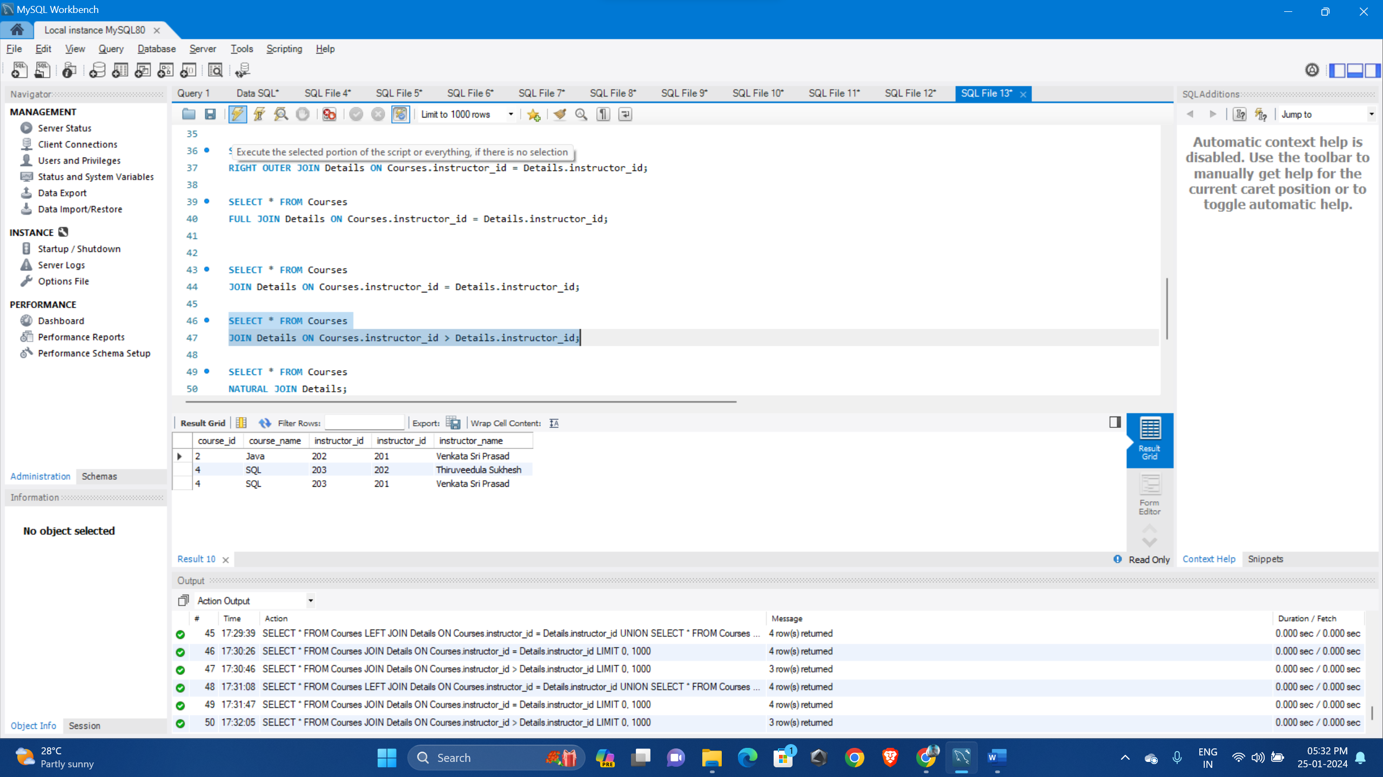

1. **Self Join:** Self join where a table is joined with itself, typically to compare rows within the same table based on certain conditions, often involving foreign key relationships.

SELECT c1.course_id, c1.course_name, c2.course_id AS related_course_id, c2.course_name AS related_course_name

FROM Courses c1

JOIN Courses c2 ON c1.instructor_id = c2.instructor_id

WHERE c1.course_id <> c2.course_id;

